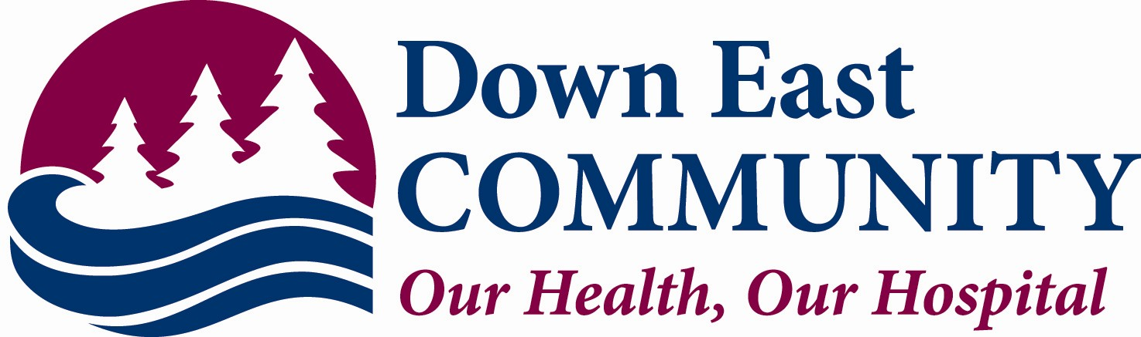

Financial Assistance Application Form Instructions
FOR SERVICES AT
ARNOLD MEMORAL MEDICAL CENTER

Thank you for requesting an application for Financial Assistance. There are a few things we must have before a determination can be made. You must be a Maine resident to apply for financial assistance.

We must have proof of all sources of income as follows:
- Household Income: All members of the household must be included on the application along with their proof of income. (Note: If anyone else can claim you as a dependent, that person must be included on the application along with their proof of income.)
- If you are actively employed or self-employed, please attach BOTH of the following types of documentation to your application:
  - Confirmation of income earned in the last 3 months, such as paystubs.
  - Confirmation of your annual income; your 2024 tax return AND copies of your W-2’s and 1099’s as applicable
- If you are receiving social security; pensions or other forms of retirement income we must have a copy of the check received or a bank statement showing the deposits made. We will also accept a copy of your yearly benefit statement from the Social Security Administration.
- If you are living on savings accounts or investments, we need two consecutive months’ statements to show that you are spending those funds to meet daily expenses.
- If you are unemployed and not receiving any income, we need a letter of support written by the person supplying your day-to-day needs.
- If you are receiving unemployment benefits we must have a copy of the check or determination letter.

The hospital reserves the right to an independent verification of income. It will be necessary for you to complete and sign form 4506T-EZ Short form request for Individual Tax Return Transcript (attached).

If you fail to provide the requested information your application will be deferred for 60 days. If you do not respond in 60 days your application will be denied. Please make sure you sign and date the application.

If you need assistance in completing the form, please feel free to call us.

Please mail to Attn: Patient Accounts, DECH, 11 Hospital Drive, Machias, ME 04654-3325

Down East Community Hospital Financial Assistance Application
Applicant(s) Name(s):
Last | First |  |  | MI | DOB
1.
2.
Address |  | City |  |  |  |  | State | Zip
Please list additional members in household: |  | Relationship |  |  |  | Date of Birth: |  | Claimed on Taxes?
GROSS INCOME | Household | Other |  |  |  | ASSETS
Weekly Salary |  |  |  |  |  | Checking/Savings
Dividends/Interest |  |  |  |  |  | Real Estate
Gross Rental Income |  |  |  |  |  | Automobiles
Self-Employment |  |  |  |  |  | Life Insurance
Social Security/Disability |  |  |  |  |  | Other Vehicles, etc.
Workers Compensation |  |  |  |  |  | MAINECARE COVERAGE
Unemployment |  |  |  |  |  | Have you applied for Mainecare?  ______Yes ______No (Check one)  “Not required if services are received at a NHSC location.”
Alimony/Child Support
Other Income
*ATTACH DOCUMENTATION  FOR ALL ENTRIES ABOVE* | TOTAL  $ | TOTAL  $
I/We certify that all the information given is true and complete. I/We give permission Down East Community Hospital to verify any facts pertaining to the provided information. PLEASE ATTACH ANY ADDITIONAL DOCUMENTATION THAT EXPLAINS YOUR FINANCIAL SITUATION.
↓↓Please sign here: Date:

THIS SECTION FOR OFFICE USE ONLY – DO NOT COMPLETE
Process Date: ____________________

Total Annual Gross Income: _______________________ Number of Dependents: ______________

APPROVAL _______  150% _____ 151 - 200% _____  Other comments | DEFERRAL _______  Proof of Income _____ | DENIAL _______  Over Income _____  Other ___________________
Coverage Period:_____________________ Next Application Date:__________________

Processor Signature:_______________________________________________________

VP of Finance Signature:____________________________________________________

FINANCIAL ASSISTANCE FOR THOSE UNABLE TO PAY

Down East Community Hospital (DECH) is committed to treating all patients who need our care regardless of their health insurance or financial status. In addition, we offer services to help you arrange for payment of your bill, from insurance billing, to payment plans, and even financial assistance, which may qualify you to have all or part of your bill written off.

DECH gives financial assistance to Maine people with family income at 150% or less of the Federal Poverty Income Guidelines as Free Care and those at 151-200% of the Federal Poverty Level as Reduced Care, which will provide a 75% reduction of the balance of your account.
Size of family unit & income guidelines:

200%FPL
100% discount
1- $31,300.00
2 $42,300.00
3 $53,300.00
4 $64,300.00
5 $75,300.00
6 $86,300.00
7 $97,300.00
8 $108,300.00

Add $11,000.00 for each family member

To apply for Financial Assistance, contact the DECH Patient Financial Services Office at 255-2590 or online at www.dech.org.

You will be asked if you have insurance of any kind to help pay for your care. You may also be asked to show that insurance or a government program will pay for your care.

Only necessary medical care is covered under our financial assistance program.
If you do not qualify for financial assistance, you are entitled to ask for a fair hearing. We will tell you how to apply for a fair hearing.
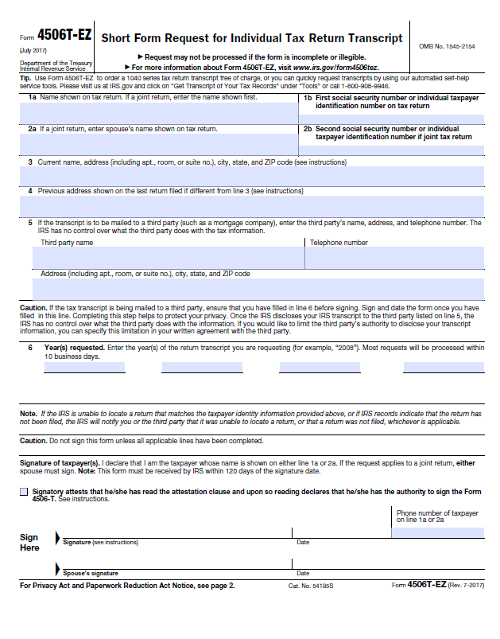

Down East Community Hospital (DECH) complies with applicable Federal civil rights laws and does not discriminate on the basis of race, color, national origin, ethnicity, age, mental or physical ability or disability, political affiliation, religion, culture, socio-economic status, genetic information, veteran status, sexual orientation, sex, gender, gender identity or expression, or language. DECH does not exclude people or treat them differently because of race, color, national origin, ethnicity, age, mental or physical ability or disability, political affiliation, religion, culture, socio-economic status, genetic information, veteran status, sexual orientation, sex, gender, gender identity or expression, or language.

Down East Community Hospital
- Provides free aids and services to people with disabilities to communicate effectively with us, such as:
○ Qualified sign language interpreters
○ Written information in other formats (large print, audio, accessible electronic formats, other formats)
- Provides free language services to people whose primary language is not English, such as:
- Qualified interpreters
- Information written in other languages

If you need these services, contact the Hospital at 207-255-3356. If you have a TTY, you may also dial 711 Maine Relay.

If you believe that Down East Community Hospital has failed to provide these services or discriminated in another way on the basis of race, color, national origin, age, disability, or sex, you can file a grievance with: Karen Theriault at 207-255-0272, email ktheriault@dech.org or fax to 207-255-0214. You can file a grievance in person or by mail, fax, or email. If you need help filing a grievance, Karen Theriault is available to help you.

You can also file a civil rights complaint with the U.S. Department of Health and Human Services, Office for Civil Rights, electronically through the Office for Civil Rights Complaint Portal, available at https://ocrportal.hhs.gov/ocr/portal/lobby.jsf, or by mail or phone at:
U.S. Department of Health and Human Services, 200 Independence Avenue, SW, Room 509F, HHH Building, Washington, D.C. 20201, 1-800-368-1019, 800-537-7697 (TDD). Complaint forms are available at http://www.hhs.gov/ocr/office/file/index.html.
English Translation: You have the right to an interpreter at no cost to you. Please point to your language






